**EXP#3 Simulation Guidelines**

**Experiment Admin:**  **Date:**

|  |  |  |  |  |
| --- | --- | --- | --- | --- |
| **Student ID No** | **Name and Surname** | **Points (for Admin)** | | |
| **Q** | **Expr** | **T** |
|  |  |  |  |  |

In this experiment, you are going to test three linear circuit theorems. Namely, **Scaling Theorem**, **Superposition Theorem** and **Reciprocity Theorem**. All theorems will be test on the same circuit (Fig 3.3). You need to reconfigure each circuit to gather the required information. Then, you are expected to fill out each following table. Finally, you should upload your final report for evaluation.

You need to study Lab manual to get familiar with the subject. And, be prepared to run simulations on LTspice.

**Test Circuit: Fig 3.3**

**Components: R1=100 Ω, R2=47 Ω, R3=47 Ω, R4=1 kΩ, R5=3.3 kΩ, R6= 330 Ω**

**A- Scaling Theorem Test**

Run the following circuit simulation for **case#1:** VX1 = 2V, **case#2**: VX1 = 4V, **case#3**: VX1 = 6V

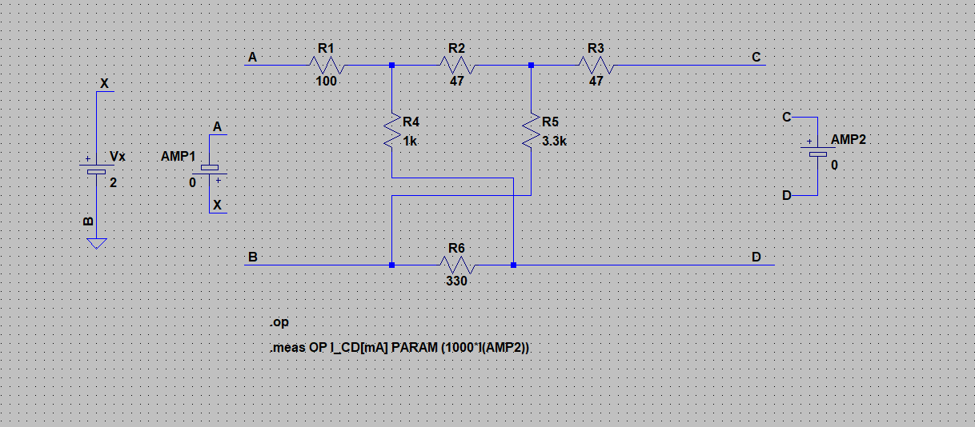

**Report Requirements**

* Include **ICD** current for each case from Spice Error Log
* Fill out Table A.1
* Verify the theorem

|  |  |  |  |  |
| --- | --- | --- | --- | --- |
| **Table A.1 Test Method: VCD = 0 and VAB is variable** | | | | |
|  | **Currents [mA]** | **Voltage Scale Factor** | **Current Scale Factor** | **Check** |
| **Case#1: VAB1 = 2 V** | **ICD1 =** |  |  |  |
| **Case#2: VAB2 = 4 V** | **ICD2 =** | **VAB2 / VAB1 =** | **ICD2 / ICD1 =** | OK? |
| **Case#3: VAB3 = 6 V** | **ICD3 =** | **VAB3 / VAB1 =** | **ICD3 / ICD1 =** | OK? |

* Include **date** and **time** from Spice Error Log for the last run

**B- Superposition Theorem Test**

Run the following circuit for **case#1:** VX1 = 5V; VX2 = 0, **case#2**: VX1 = 0; VX2 = 5V, and **case#3:** VX1 = 5; VX2 = 5 V

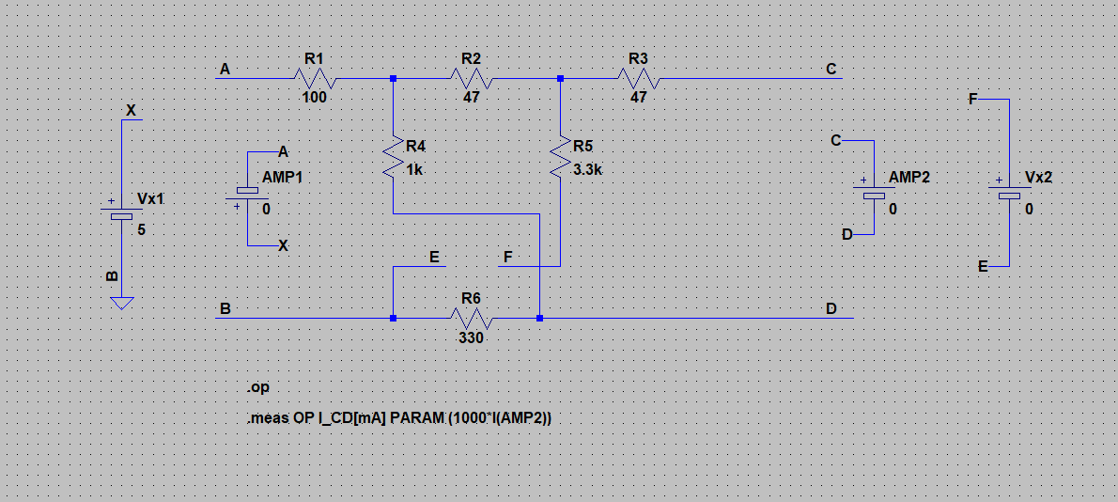

**Report requirements**

* Include **ICD** current for each case from Spice Error Log
* Fill out Table B.1
* Verify the theorem

|  |  |  |  |
| --- | --- | --- | --- |
| **Table B.1 Test Method: VCD = 0 V, VAB and VFE are variable** | | | |
|  | **Currents [mA]** | **Test** | **Check** |
| **Case#1: VAB1 = 5 V; VFE1 = 0 V** | **ICD1 =** | **ICD3 =? ICD1 + ICD2** | OK? |
| **Case#2: VAB2 = 0 V; VFE2 = 5 V** | **ICD2 =** |
| **Case#3: VAB3 = 5 V; VFE3 = 5 V** | **ICD3 =** |

* Include **date** and **time** from Spice Error Log for the last run

**C- Reciprocity Theorem Test**

Run the following circuit for **case#1:** VX1 = 5V; VX2 = 0, **case#2**: VX1 = 0; VX2 = 5V

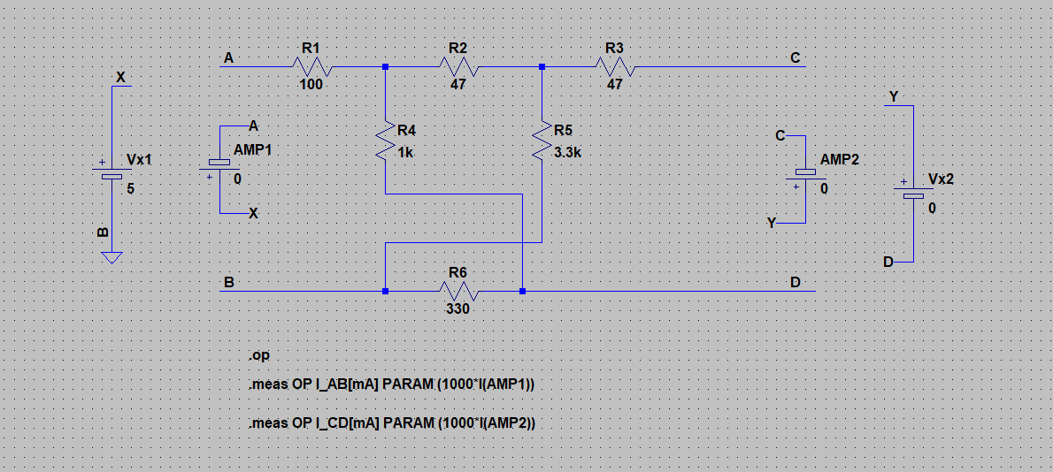

**Report requirements**

* Include **IAB** and **ICD** currents for each case from Spice Error Log
* Fill out Table C.1
* Verify the theorem

|  |  |  |  |
| --- | --- | --- | --- |
| **Table C.1 Test Method: VCD , VAB are interchanged** | | | |
|  | **Current [mA]** | **Test** | **Check** |
| **Case#1: VAB1 = 5 V; VCD1 = 0 V** | **IAB1 = ICD1 =** | **IAB2 =? ICD1** | OK? |
| **Case#2: VAB1 = 0 V; VCD2 = 5 V** | **IAB2 = ICD2 =** |

**D- Generalized Reciprocity Theorem Test (The Circuit in Fig 3.4)**

Run **section-C** circuit for **case#1:** VX1 = 5V; VX2 = 10, **case#2**: VX1 = 10; VX2 = 5V

|  |  |  |  |
| --- | --- | --- | --- |
| **Table D.1** **Test Method: VAB and VCD are interchanged** (**T** for matrix transpose) | | | |
|  | **Current [mA]** | **Test** | **Check** |
| **Case#1: VAB1 = 5 V; VCD1 = 10 V** | **IAB1 = ICD1 =** | **[V1T][I2 ]=? [V2T][I1 ]** | OK? |
| **Case#2: VAB2 = 10 V; VCD2 = 5 V** | **IAB2 = ICD2 =** |

**[V1T][I2 ] =**

**[V2T][I1 ]** **=**

**Please report any error to** [**ozayan@itu.edu.tr**](mailto:ozayan@itu.edu.tr) **[R2021.1, AD]**